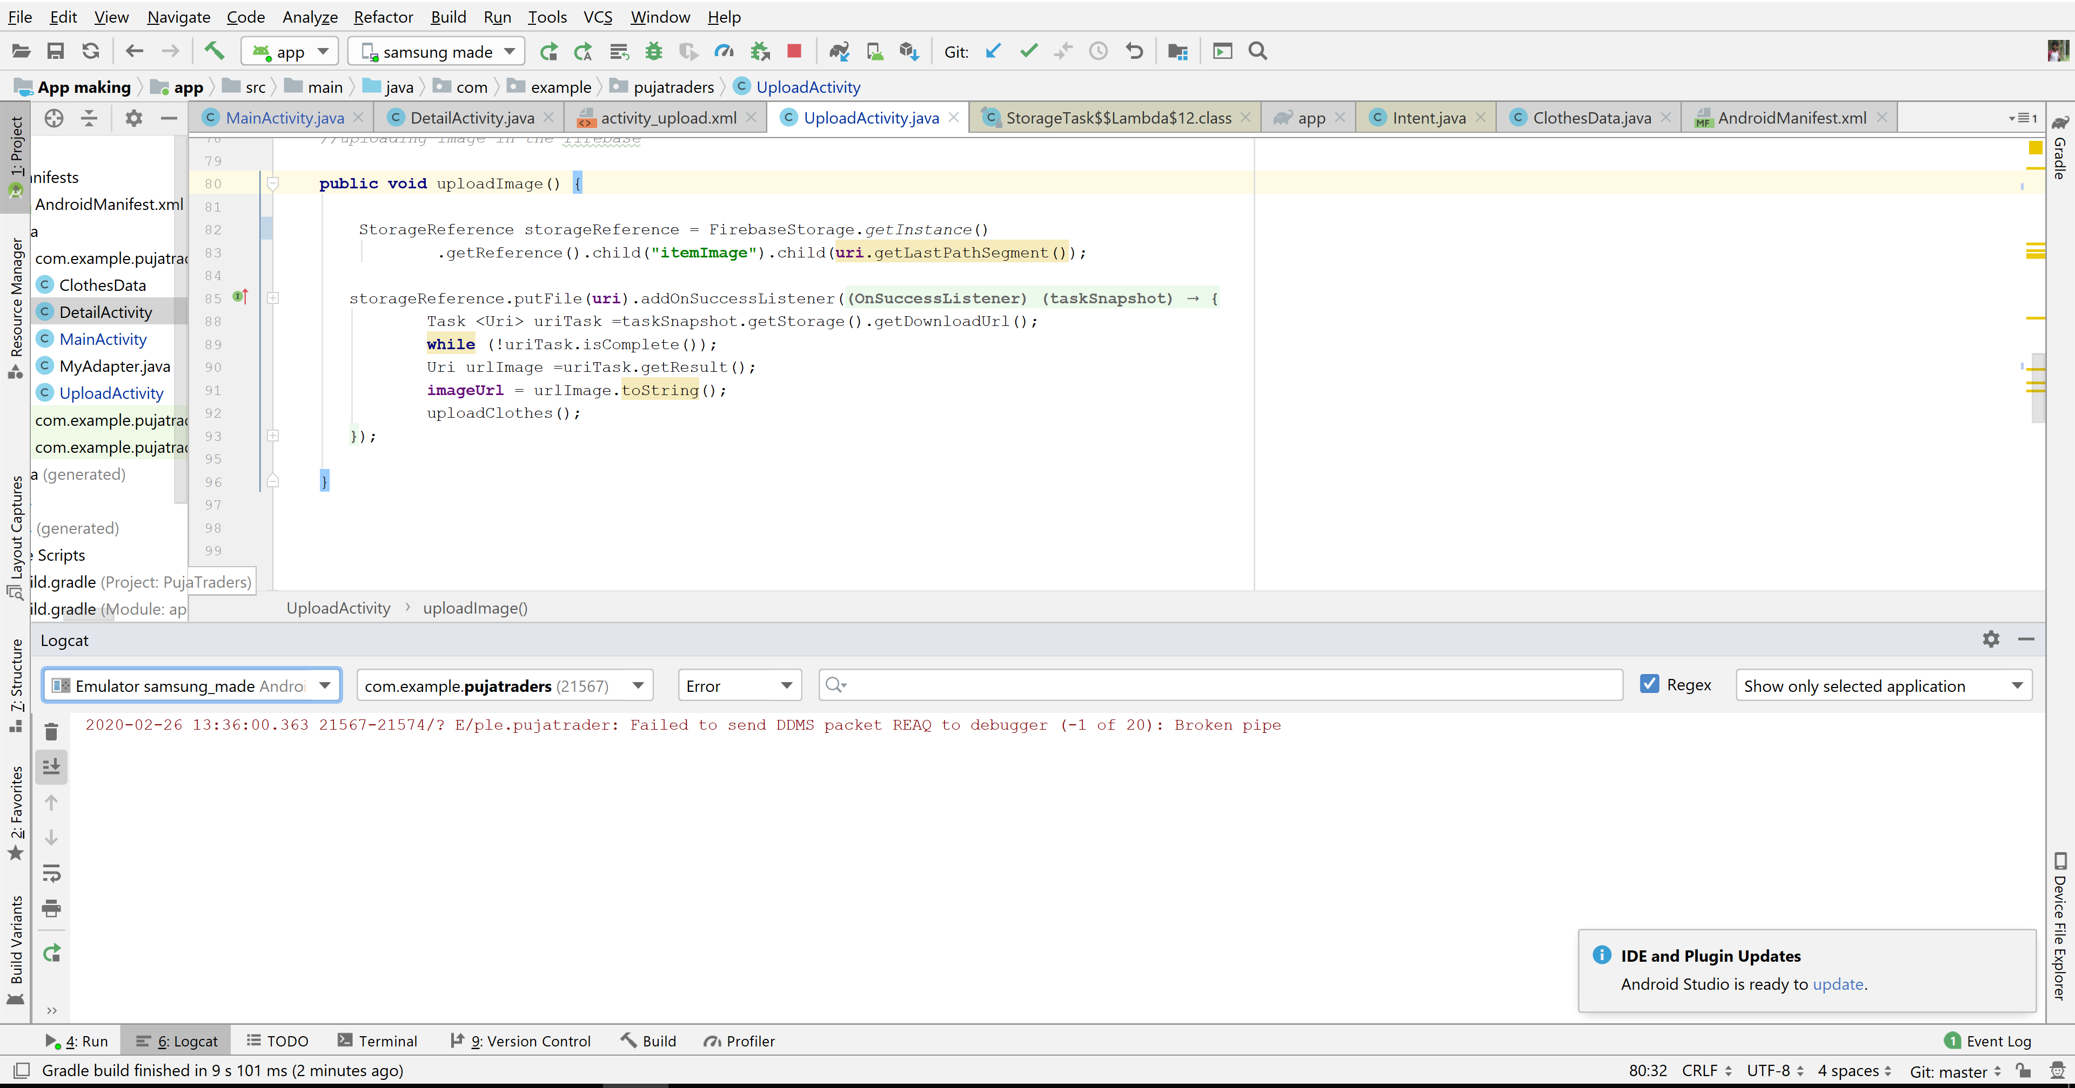

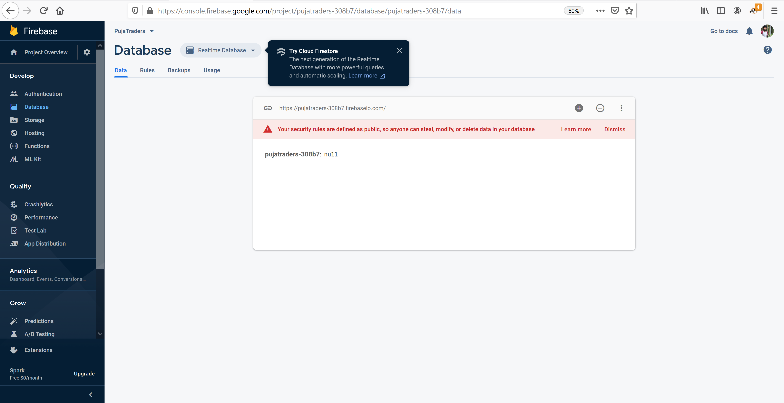

**Broken pipe error seen uploading the items in database while storage shows every image uploaded as given below:**

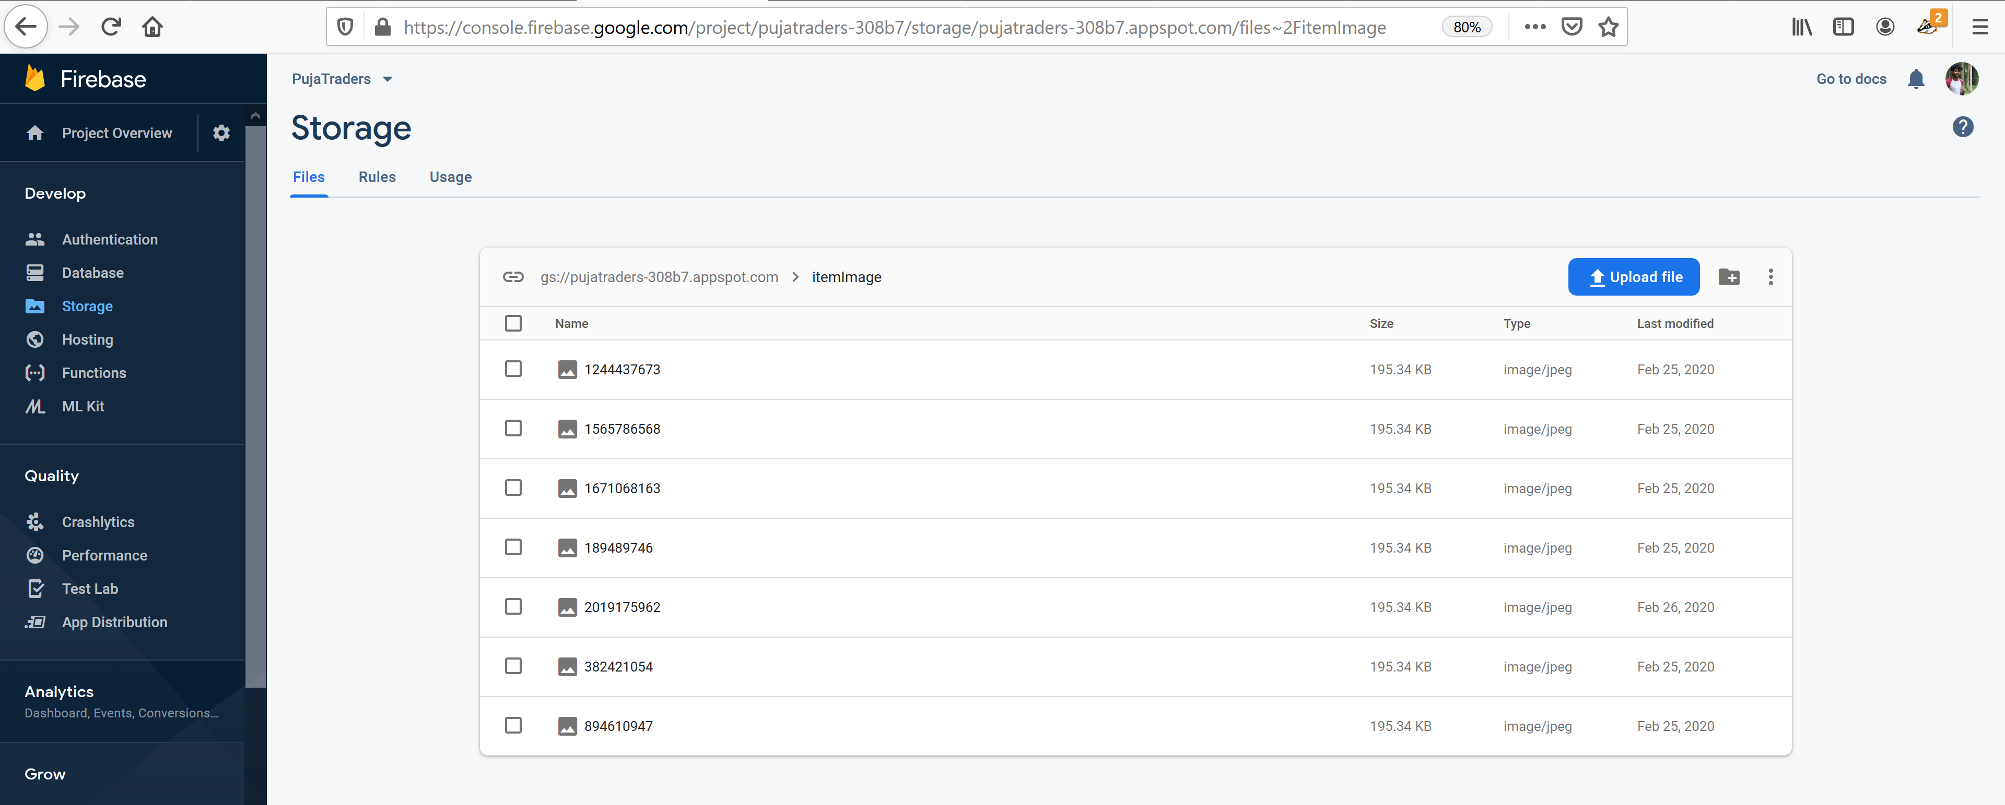

**Sign in method firebase enabling Anonymous solves the issue though unable to have files in database**

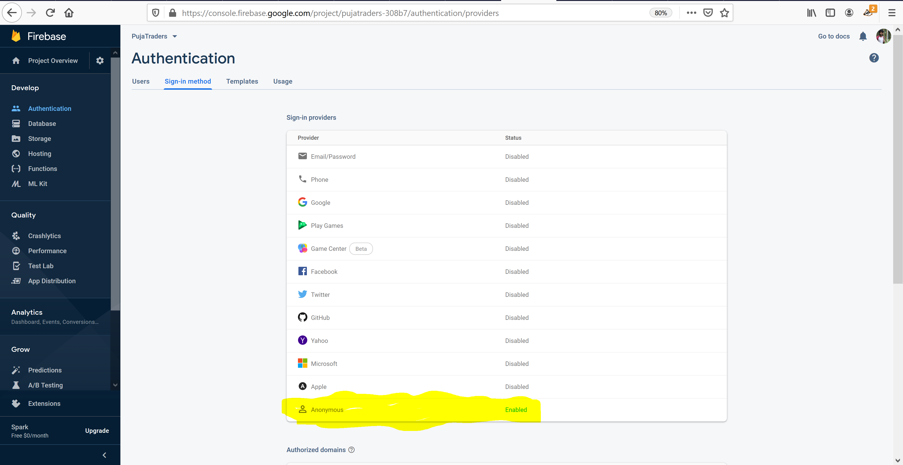

**Now The error seems as below:**

